**LAB 4 Advanced Software Engineering**

**REST Web Service**

**Convert integer To Binary**

A Rest service was created using visual studio as followed by the tutorial. In this one can call the service and give a integer as a input and convert it to a binary number.

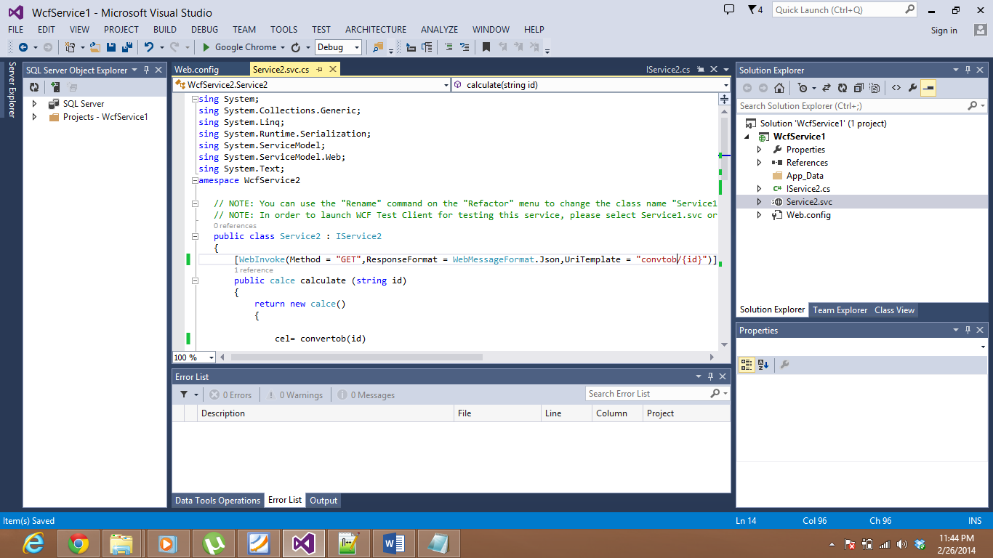

Right clicked on Service.svc was to select view on browser.

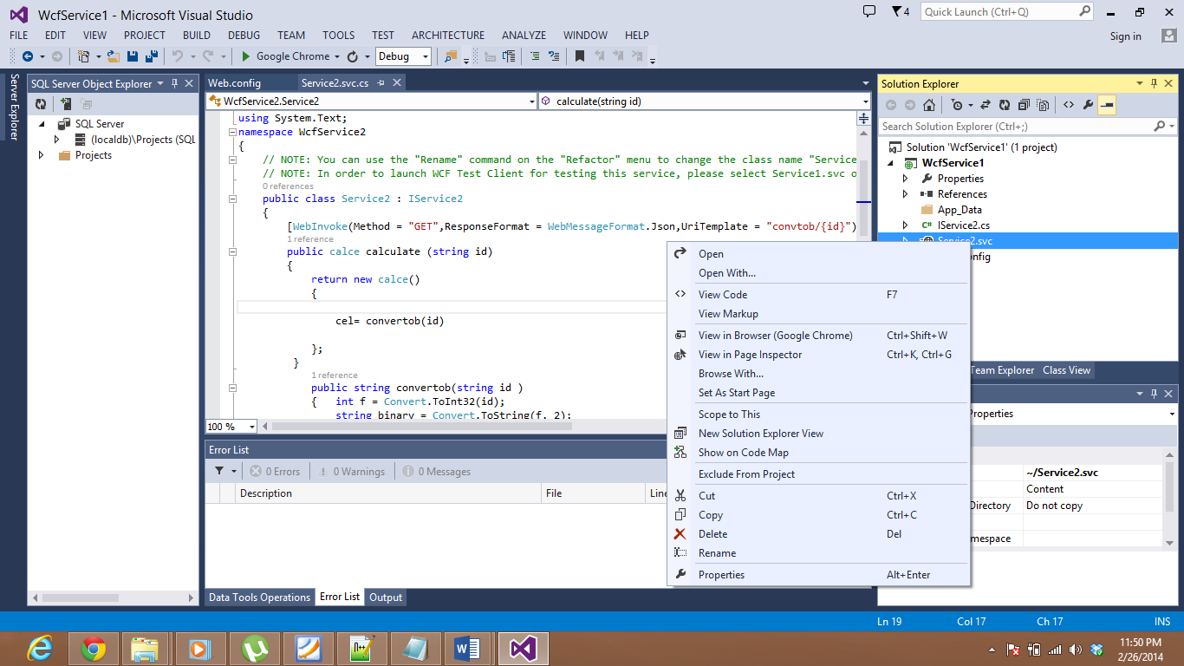

Input is given in the url as <http://localhost:12741/Service2.svc/convtob/5> where convtob is the method and 5 is the input. Hence the output is given as:

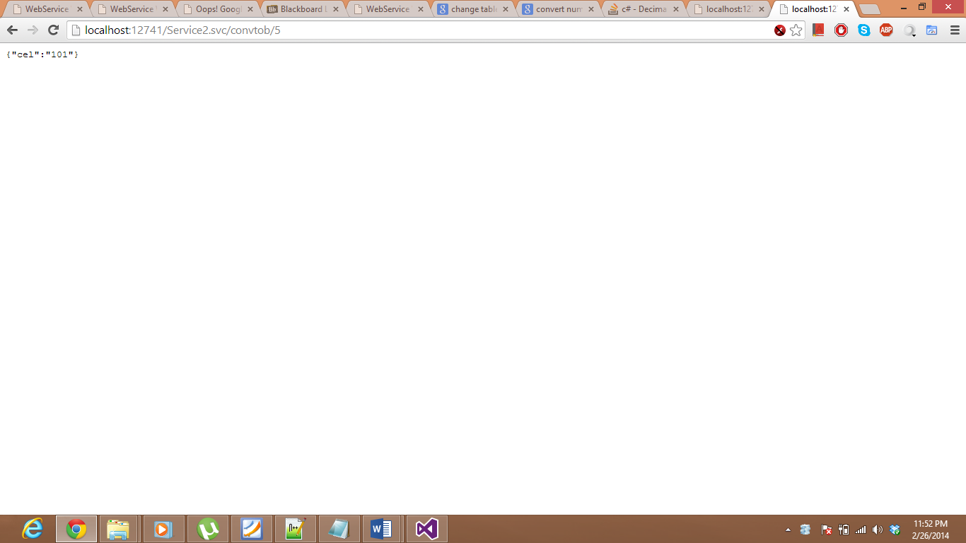

101 is the output we got.